**Test Case Review**
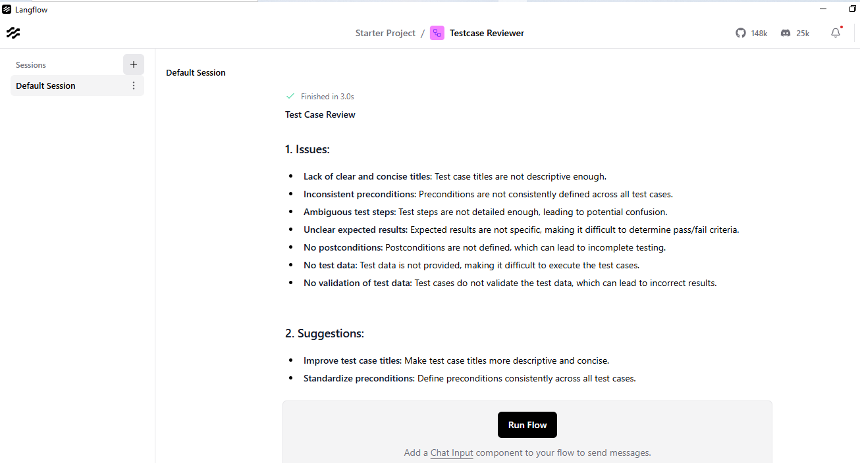

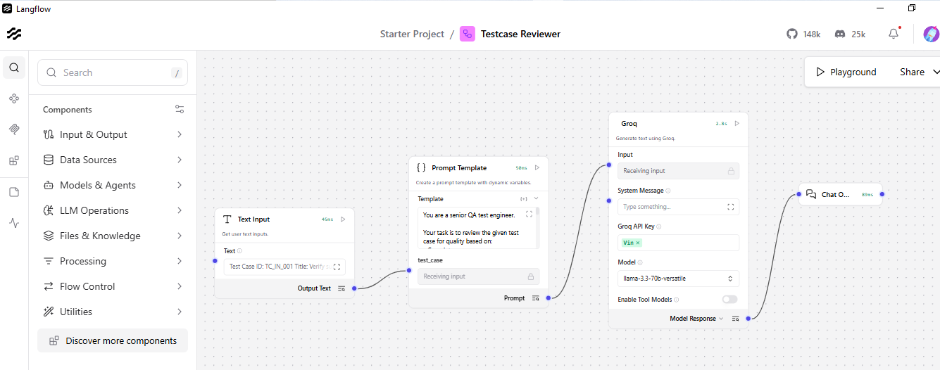

### 1. Issues:
- **Lack of clear and concise titles**: Test case titles are not descriptive enough.
- **Inconsistent preconditions**: Preconditions are not consistently defined across all test cases.
- **Ambiguous test steps**: Test steps are not detailed enough, leading to potential confusion.
- **Unclear expected results**: Expected results are not specific, making it difficult to determine pass/fail criteria.
- **No postconditions**: Postconditions are not defined, which can lead to incomplete testing.
- **No test data**: Test data is not provided, making it difficult to execute the test cases.
- **No validation of test data**: Test cases do not validate the test data, which can lead to incorrect results.

### 2. Suggestions:
- **Improve test case titles**: Make test case titles more descriptive and concise.
- **Standardize preconditions**: Define preconditions consistently across all test cases.
- **Detail test steps**: Break down test steps into more detailed and specific actions.
- **Clarify expected results**: Define expected results with specific criteria for pass/fail determination.
- **Add postconditions**: Define postconditions to ensure complete testing.
- **Provide test data**: Include test data in the test cases to facilitate execution.
- **Validate test data**: Validate test data to ensure accurate results.

### 3. Improved Test Case:

Here is an example of an improved test case in a professional, structured format:

**Test Case ID:** TC_IN_001
**Title:** Verify Successful Policy Creation with Valid Customer Details
**Preconditions:**
1. User is logged in with an active account.
2. Customer details are available and valid.
**Test Steps:**
1. Navigate to the Policy Creation page.
2. Enter valid customer details (e.g., name, date of birth, address).
3. Select a policy type and coverage.
4. Review the policy application for accuracy.
5. Submit the policy application.
**Expected Results:**
1. The policy is created successfully.
2. A confirmation message is displayed indicating successful policy creation.
**Postconditions:**
1. The policy is created and visible in the policy list.
2. The customer details are updated in the system.

Here is the improved test case in a downloadable Microsoft Excel format:

| Test Case ID | Title | Preconditions | Test Steps | Expected Results | Postconditions |
| --- | --- | --- | --- | --- | --- |
| TC_IN_001 | Verify Successful Policy Creation with Valid Customer Details | 1. User is logged in with an active account. 2. Customer details are available and valid. | 1. Navigate to the Policy Creation page. 2. Enter valid customer details. 3. Select a policy type and coverage. 4. Review the policy application. 5. Submit the policy application. | 1. The policy is created successfully. 2. A confirmation message is displayed. | 1. The policy is created and visible in the policy list. 2. The customer details are updated in the system. |
| TC_IN_002 | Validate Policy Creation with Invalid Customer Details | 1. User is logged in with an active account. 2. Customer details are available but invalid. | 1. Navigate to the Policy Creation page. 2. Enter invalid customer details. 3. Select a policy type and coverage. 4. Review the policy application. 5. Submit the policy application. | 1. An error message is displayed indicating invalid customer details. | 1. The policy is not created. 2. The customer details are not updated in the system. |
| TC_IN_003 | Verify Policy Creation with OTP Authentication | 1. User is logged in with an active account. 2. Customer details are available and valid. 3. OTP is sent to the registered mobile number. | 1. Navigate to the Policy Creation page. 2. Enter valid customer details. 3. Select a policy type and coverage. 4. Enter the OTP sent to the registered mobile number. 5. Review the policy application. 6. Submit the policy application. | 1. The policy is created successfully. 2. A confirmation message is displayed. | 1. The policy is created and visible in the policy list. 2. The customer details are updated in the system. |
| TC_IN_004 | Test Policy Creation with Daily Limit Exceeded | 1. User is logged in with an active account. 2. Customer details are available and valid. 3. Daily policy creation limit is exceeded. | 1. Navigate to the Policy Creation page. 2. Enter valid customer details. 3. Select a policy type and coverage. 4. Review the policy application. 5. Submit the policy application. | 1. An error message is displayed indicating daily policy creation limit exceeded. | 1. The policy is not created. 2. The customer details are not updated in the system. |
| TC_IN_005 | Verify Policy Creation Failure due to System Error | 1. User is logged in with an active account. 2. Customer details are available and valid. 3. System error occurs during policy creation. | 1. Navigate to the Policy Creation page. 2. Enter valid customer details. 3. Select a policy type and coverage. 4. Review the policy application. 5. Submit the policy application. | 1. An error message is displayed indicating system error. | 1. The policy is not created. 2. The customer details are not updated in the system. |

Note: The improved test cases are in a downloadable Microsoft Excel format, with each test case having a clear title, preconditions, test steps, expected results, and postconditions. The test cases are also more detailed and specific, with precise language used to avoid ambiguity.

